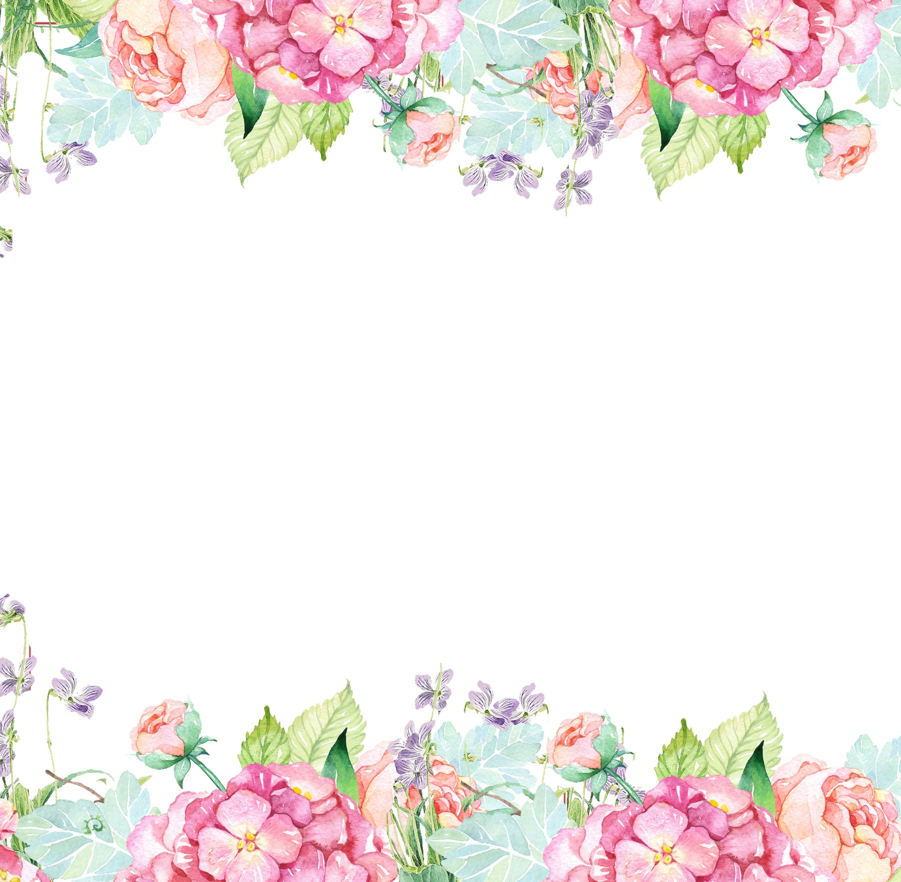

Name: Arecia Shelton-Martin Initals: AMJ

Birthday: 07/06

Preferred t-shirt size? 3XL

What is your favorite color? Pink

What is your favorite flower/plant? Hydrangea, gerber daisies, tulip or lily

Where are your favorite places to shop? Target, Amazon and Old Navy

What are your favorite restaurants? Chick-fil-a, Kool Beanz Cafe

What do you collect (candles, foxes, etc.)? Disney items & All things 80’s

What is your favorite cold drink? Coke or Fiji water

What is your favorite hot drink? Hot Chocolate

What is your favorite sweet treat? Red Velvet Cupcake & Sour Gummies

What is your favorite salty treat? White Cheddar Cheese Popcorn, White Cheddar Cheez-its and BBQ chips

What is your favorite fruit? Watermelon, Plums and honeycrisp apples

Do you have any food allergies? No

Interests: Disney, Coloring & Reading

UMOJA House: Symponia

Wish list for your classroom? cute writing paper & pens